SUBJECT: Software Design 2
Code: SDN260S | Submission Date: 01 November  2026

FACULTY OF ENGINEERING AND THE BUILT
ENVIRONMENT
DEPARTMENT OF ELECTRICAL, ELECTRONIC AND
COMPUTER
ENGINEERING
Bachelor of Engineering Technology in Computer Engineering :2nd year
Check-In 3: Final Integration & Testing
No | Name & Surname | Student Number | Contribution out of  100%
1. | Mnqobi Gumede | 240966120 | 100%
2. | Mixo Makhongele | 240342534 | 100%
3. | Ntsakisi Mahunisi | 240926072 | 100%
4. | Khuthadzo Makuya | 240087070 | 100%
5. | Thingahangwi Tshivhundo | 230550878 | 100%
6. | Mulanga Phalanndwa | 222505932 | 100%
7. | Zwavhudi Ramagadza | 250391449 | 100%
8. | Mukhethwa Bulwana | 231234481 | 100%

Contents
Part A: README and User Guide 4
A1. About RepoSpace 4
A2. Features 4
A3. Requirements 5
A4. Installation and running 5
A5. User guide 6
A5.1 Create an account and log in: 6
A5.2 Home screen 7
A5.3 Create a repository and make your first commit 8
A5.4 Work with versions 11
A5.5 Projects 12
A5.6 Find other people and download their work 14
A5.7 Your profile and settings 15
A6. Public and private items 17
A7. GitHub-style features 17
A8. Where your data is stored 18
A8.1 Running the tests 19
A9. Troubleshooting 19
A10. Project structure 20
A11. How it works 21
A12. Known limitations 21
Part B: Software Design Report 22
B1. Introduction 22
B2. Requirements 23
B3. System architecture 24
B4. Detailed design: classes 25
B5. Behaviour: key flows 26
B6. Data design 26
B7. Design decisions 27
B8. Implementation 27
B9. Testing 28
B10. Limitations and future improvements 28
B11. Conclusion 29
Part C: GA2 and GA7 Reflection 29
GA2: Application of Scientific and Engineering Knowledge 29
GA7: Sustainability and impact of engineering activity 30

Part A: README and User Guide

A1. About RepoSpace

A simple version control system for students and small teams.
Repospace is a desktop application written in Java and JavaFX. It watches a folder on your computer and lets you save numbered snapshots of it (commits), look back at every change, restore any earlier version, and share finished work with other users. Think of it as a small, friendly Git with a graphical interface.
Built for SDN260S Software Design 2(topic 19: Simple Version Control System), Cape Peninsula University of Technology.

A2. Features
Area | What you can do
Accounts | Register, log in with username or e-mail, edit your profile and settings
Version control | Commit a folder with a message, see exactly which files were added, modified or deleted, restore any version, clone or download the latest version as a ZIP
Sharing | Make projects, repositories and your profile public or private; search for other users; view their public profiles; download their public repositories
Extras | Repository README and About box, pinned repositories, releases, wiki, discussions, project boards, sponsor tiers, a local Pages website, profile statistics and badges
Look and feel | Light and dark themes in the Repospace logo colours

A3. Requirements
Needed | Version | Notes
Java JDK | 17 or newer (21 recommended) | The JDK, not just the JRE
Apache  NetBeans | 17 or newer | Maven support is built in. Any IDE that opens Maven projects also works
Apache Maven | 3.8 or newer | Included with NetBeans; install it separately only if you build from a terminal
Internet connection | First build only | Maven downloads JavaFX 21.0.2, the SQLite driver 3.45.1.0 and JUnit 5.10.2
Screen | 1024 x 768 or larger | The window opens at 980 x 640
Disk space | About 200 MB for dependencies, plus space for your snapshots
No database server is needed. SQLite creates its own files the first time the program starts.

A4. Installation and running
Option A - Apache NetBeans (recommended):
- Unzip the project. You should have a folder named Repospace that contains pom.xml.
- In NetBeans choose File > Open Project… and select that folder.
- Wait while NetBeans downloads the dependencies (progress bar at the bottom right).
- Right-click the project and choose Clean and Build.
- Press Run (F6). If NetBeans asks for a main class, choose com.repospace.Repospace. If Run does nothing: right-click the project > Run Maven > Goals…, type javafx:run, and press OK.

Option B – Terminal: cd Repospace mvn clean javafx:run
To build without running: mvn clean package.
Try it with sample data:
The sandbox/ folder holds practice material:
- sandbox/sample-project is a small normal folder to track.
- sandbox/edge-cases holds an empty file, a binary file, a file name with spaces, a file five folders deep and an empty folder.
Copy a folder out of sandbox/ before tracking it, so the original stays unchanged.

A5. User guide

A5.1 Create an account and log in:
- On the login screen click Create a new account.
- Fill in:
  - Username: 3 to 30 characters. Letters, digits, ., _ and - only. No spaces. Example:
khuthadzo.makuya.
  - E-mail: a valid address, for example name@example.com. – Password: at least 8 characters.
- Press Create an account, then log in with your username or your e-mail address and your password.
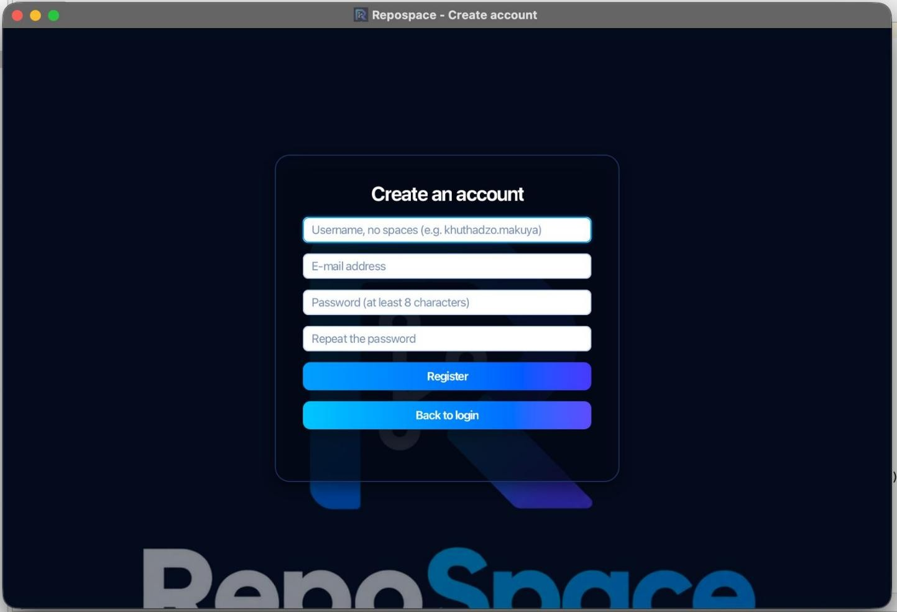
Figure 1: Create an account screen. The username must have no spaces, the password at least 8 characters, and the password is typed twice.
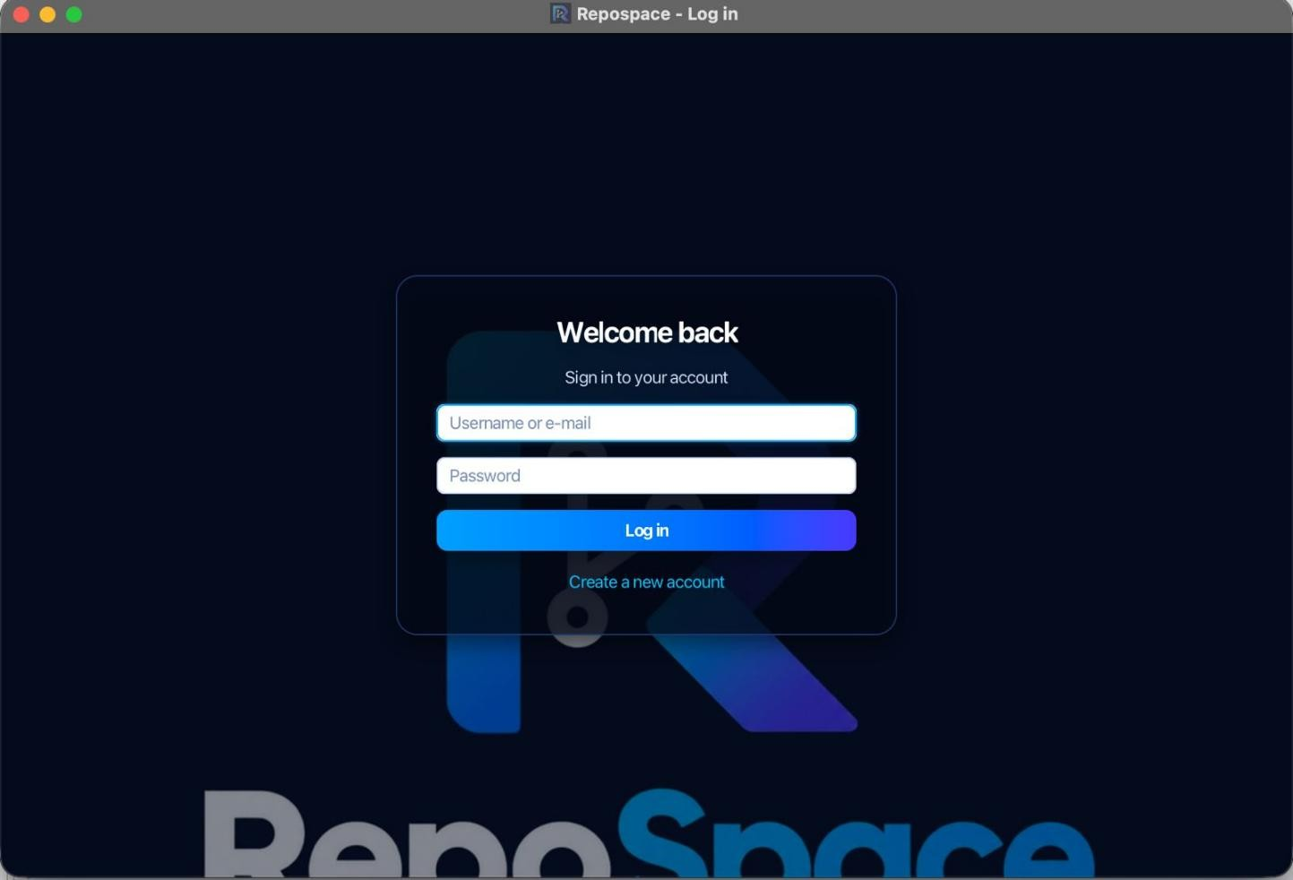
Figure 2: Log in screen. Users sign in with their username or e-mail and password.
Your password is stored only as a salted hash, never as plain text.

A5.2 Home screen
After logging in you see the home screen with a sidebar:
Button | Opens
Home | Welcome page
Projects | Your project list and project boards
Repositories | Version control: commit, history, restore, download
Discover | Search for other users and public repositories
My page | Your public page: README, pinned repositories, badges, activity
Edit profile | Bio, picture, README, status and profile visibility
Settings | Theme, language preference, notifications
Log out | Ends your session
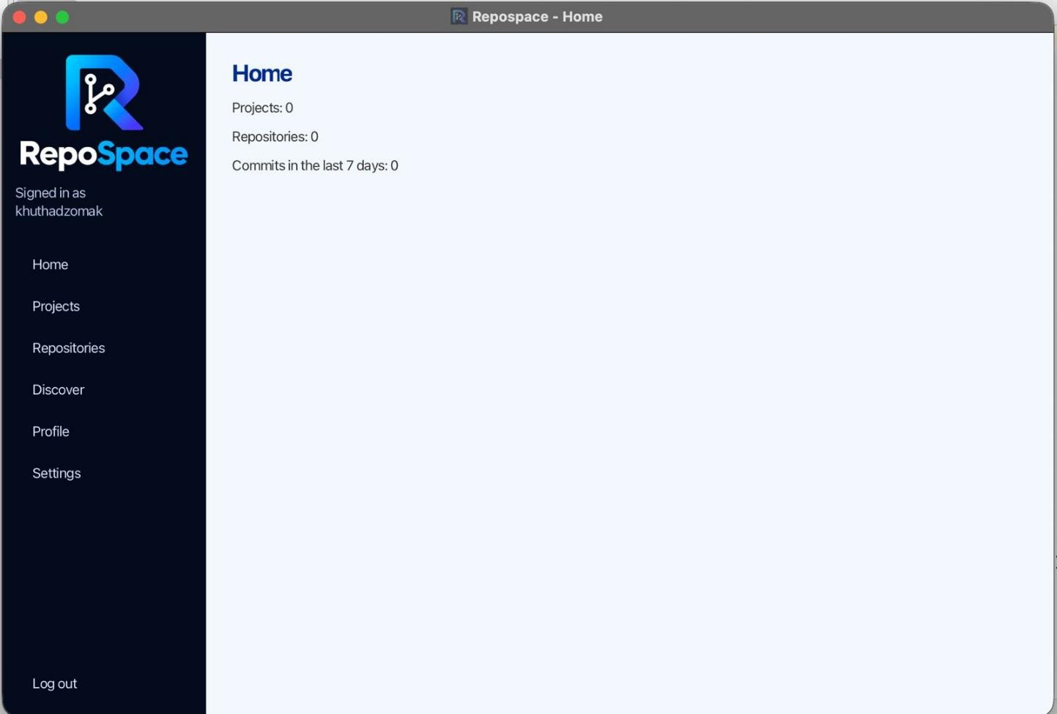
Figure 3: Home screen after signing in as khuthadzomak, showing the number of projects, repositories and commits in the last 7 days.

A5.3 Create a repository and make your first commit
- Click Repositories, then New repository.
- Enter a name, choose Public or Private (private is the default), press Browse… to select the folder you want to track, and press Create repository.
- Select the repository in the list, type a message such as First version, and press Commit. Your first commit is stored as v1.
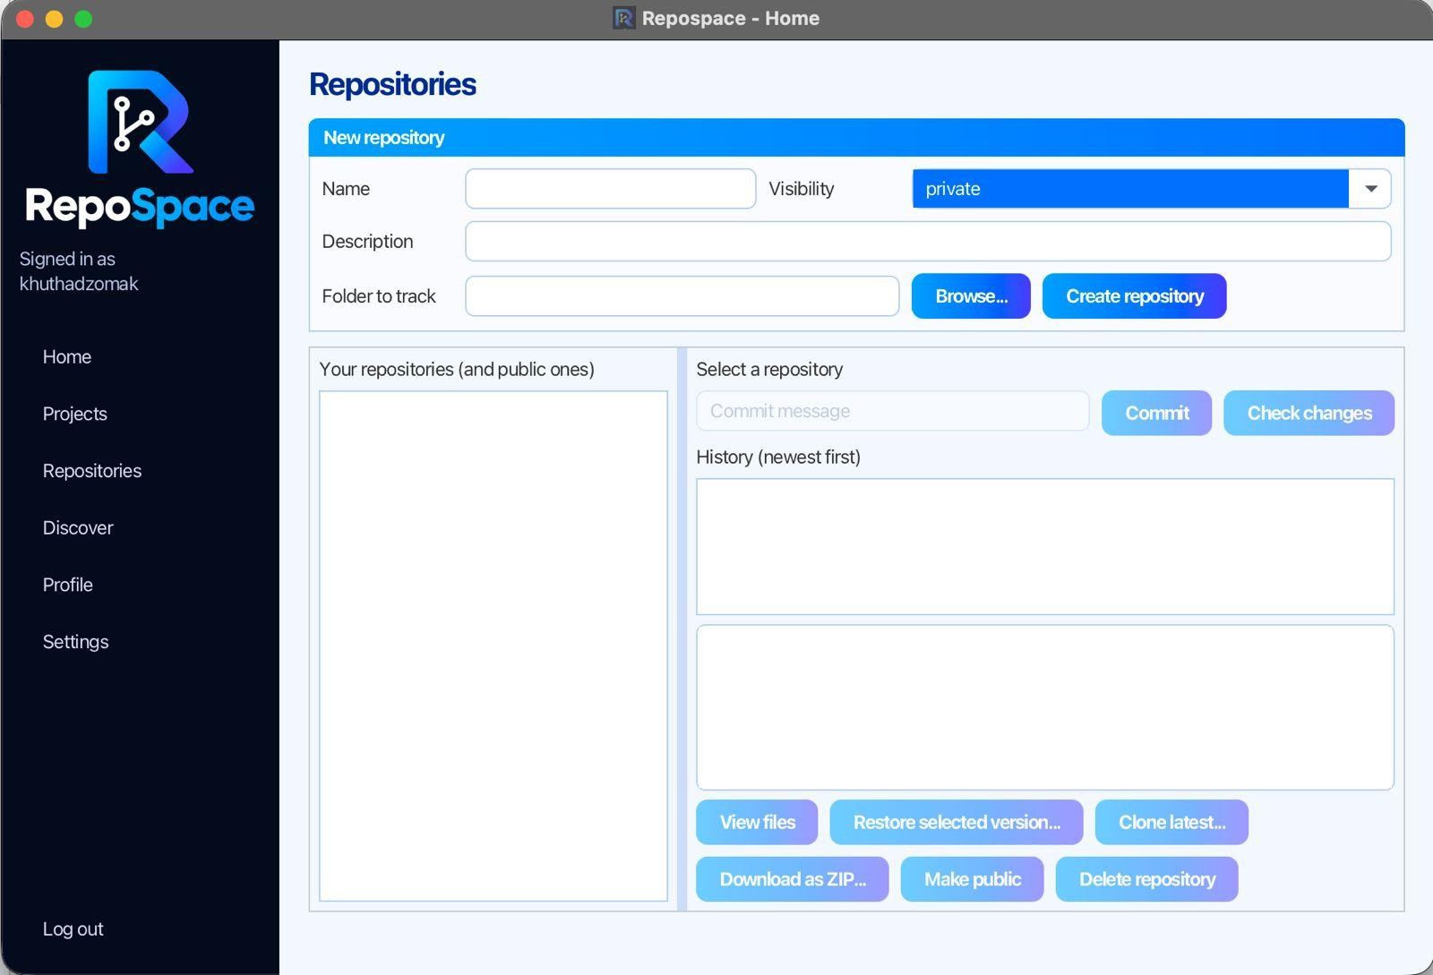
Figure 4: Repositories screen before any repository is created. Commit and the other actions stay disabled until a repository is selected.
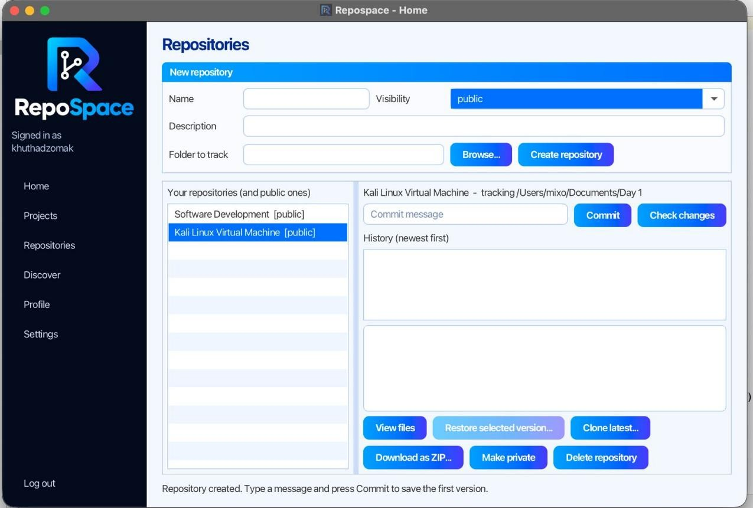
Figure 5: Output after creating a repository: the new repository appears in the list and the status line reads "Repository created. Type a message and press Commit to save the first version."
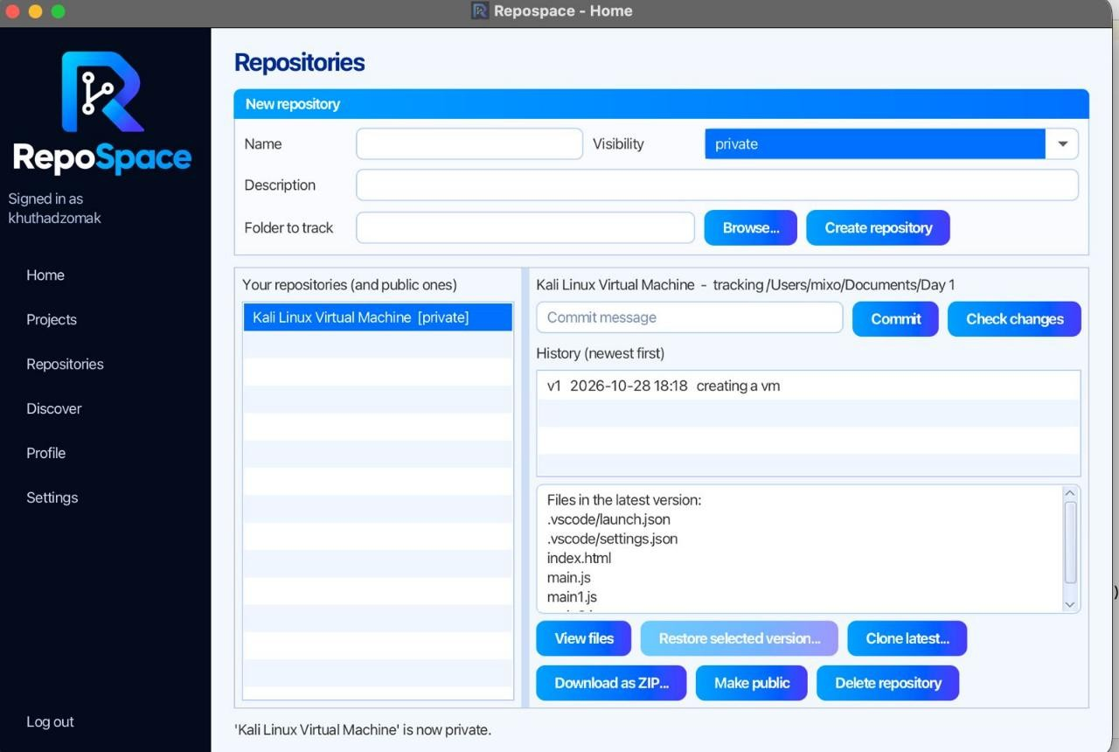
Figure 6: First commit saved as v1 (2026-10-28 18:18, message "creating a vm"), with the files in the latest version listed below the history.

Large folders are processed in the background, so the window stays responsive.

A5.4 Work with versions
Action | How
Save a new version | Change files in the tracked folder, press Check changes to preview (ADDED, MODIFIED,  DELETED), then type a message and press Commit. You get v2, v3 and so on
See what a version changed | Click a version in the history list. You see who made it, when, and which files were added, modified or deleted
Go back to an older version | Select the version and press Restore selected version…. Choose an empty folder; the old files are written there. Your tracked folder is not changed
Copy the latest version | Clone latest… copies the newest version into an empty folder
Action | How
Download as a ZIP | Download as ZIP… saves the newest version as one .zip file. Works for your own repositories and for other users’ public ones
Browse files | View files lists the files of the latest version
Change visibility | Make public or Make private (owner only)
Remove a repository | Delete repository deletes Repospace’s saved versions. Your original folder is never touched

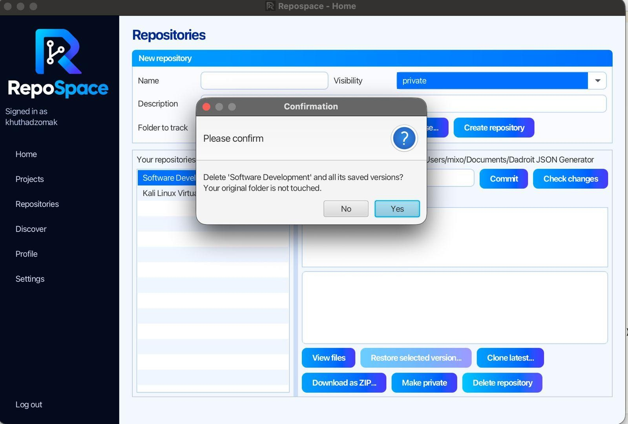
Figure 7: Deleting a repository asks for confirmation first. Only Repospace's saved versions are deleted; the original folder is not touched.

A5.5 Projects
Use Projects as a to-do list for your work.
- Enter a name and description, choose Public or Private, set a status and press Add project.
- Select a project and press Set status of selected to change its status, or use Make selected public / private to change who can see it (making a project public asks you to confirm).
- Press Open board (or double-click the project) to see its kanban board with To do, In progress and Done columns, cards and a progress bar.
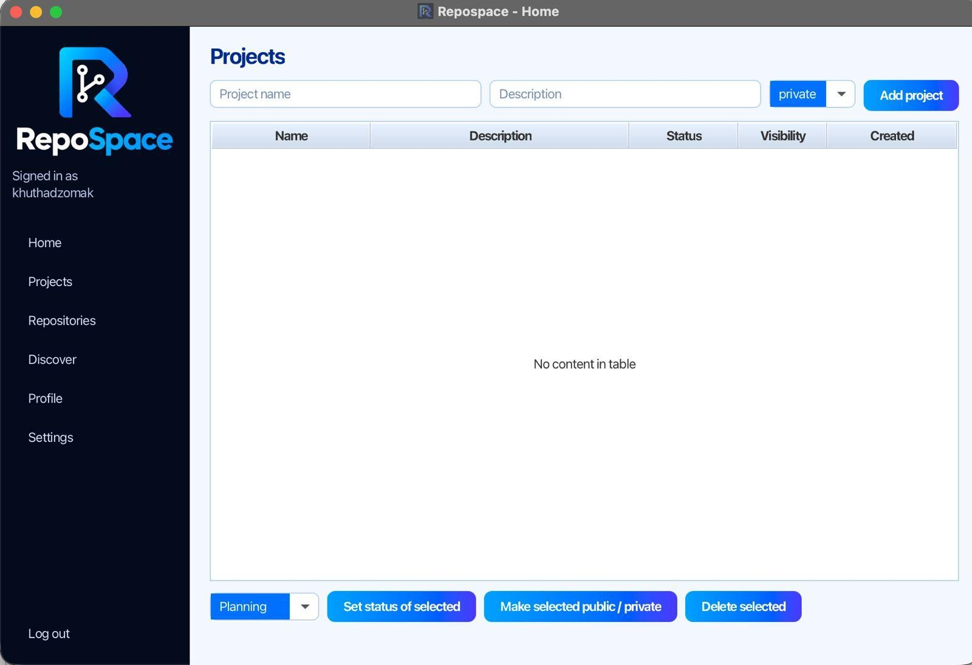
Figure 8: Projects screen before any project is added.
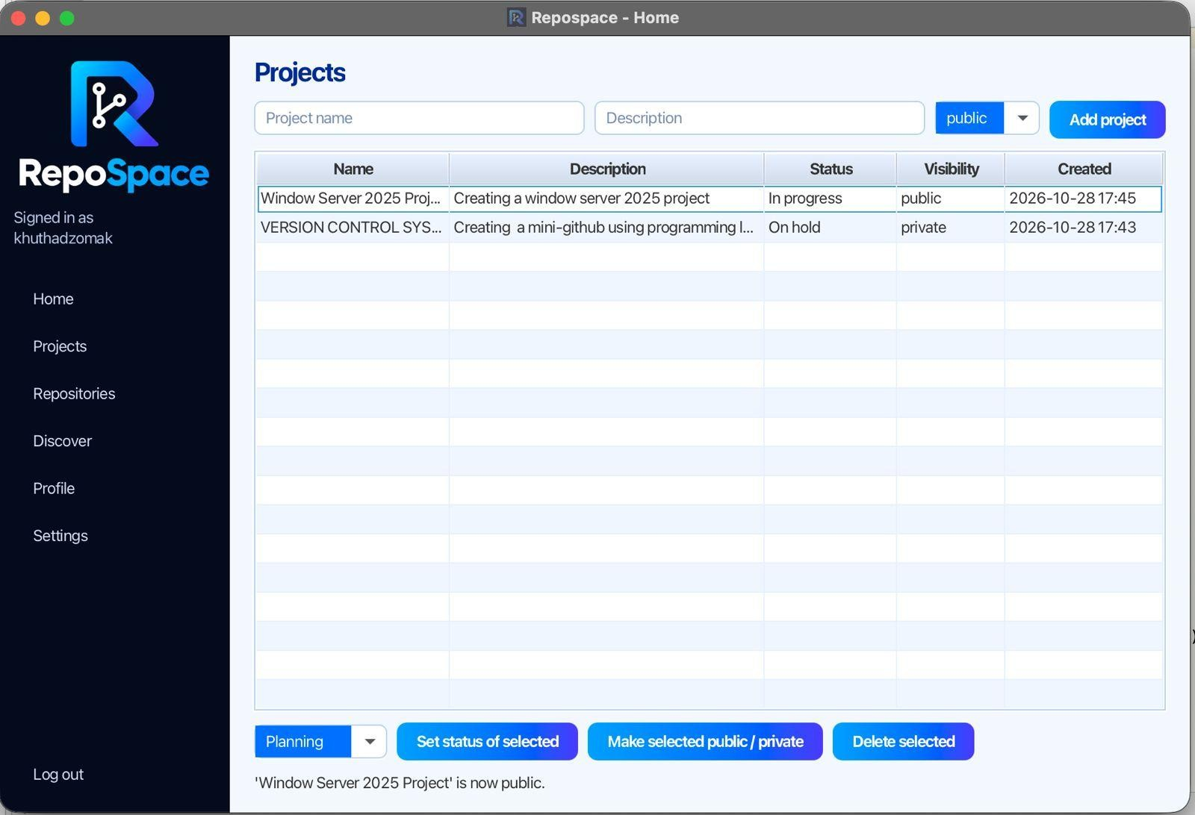
Figure 9: Two projects with their status, visibility and creation date. The status line confirms "'Window Server 2025 Project' is now public."

A5.6 Find other people and download their work
- Open Discover. Choose People or Repositories in the drop-down.
- Type part of a username (or, in Repositories mode, a name, description or topic) and press Search.
- Select a user to see their profile, their public projects and their public repositories.
- Select a public repository and choose Download as ZIP… or Download to a folder….
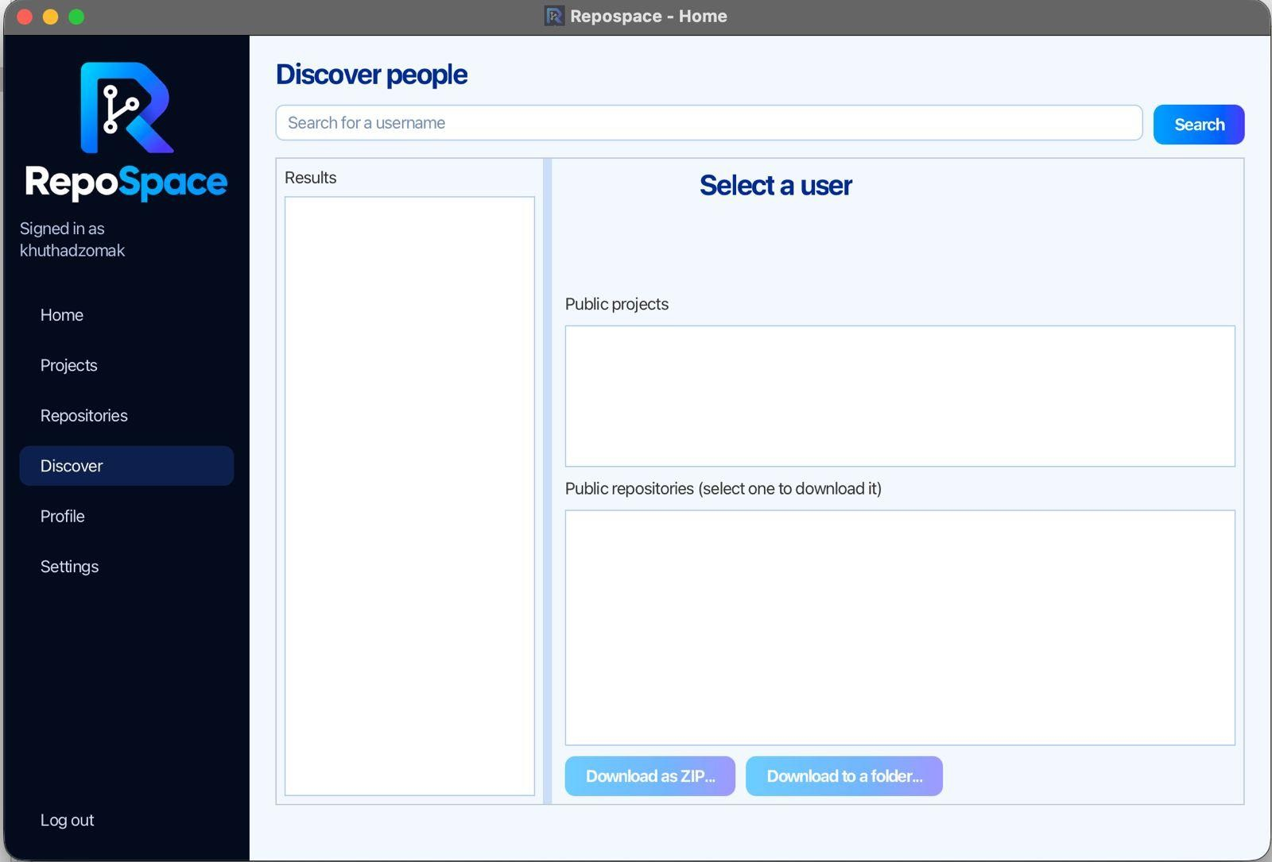
Figure 10: Discover screen before a search.
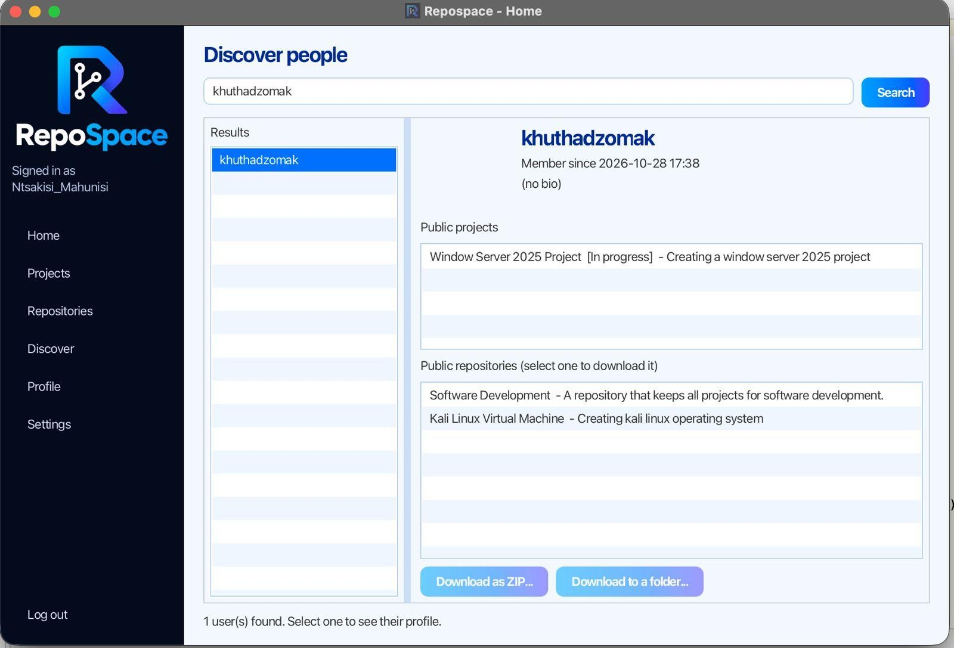
Figure 11: A second user, Ntsakisi_Mahunisi, searches for khuthadzomak. Only the public project and public repositories are shown; the private project "VERSION CONTROL SYSTEM" from Figure 9 is not listed.
Private items are never listed and cannot be downloaded. Other users never see your e-mail address.

A5.7 Your profile and settings
- Edit profile: change your username, e-mail, bio and picture; write a profile README and a status line; choose Public or Private. A private profile shows other users only your username.
- Settings: switch between Light and Dark themes, set your language preference and turn notifications on or off. (The language setting is saved, but the screens are in English.)
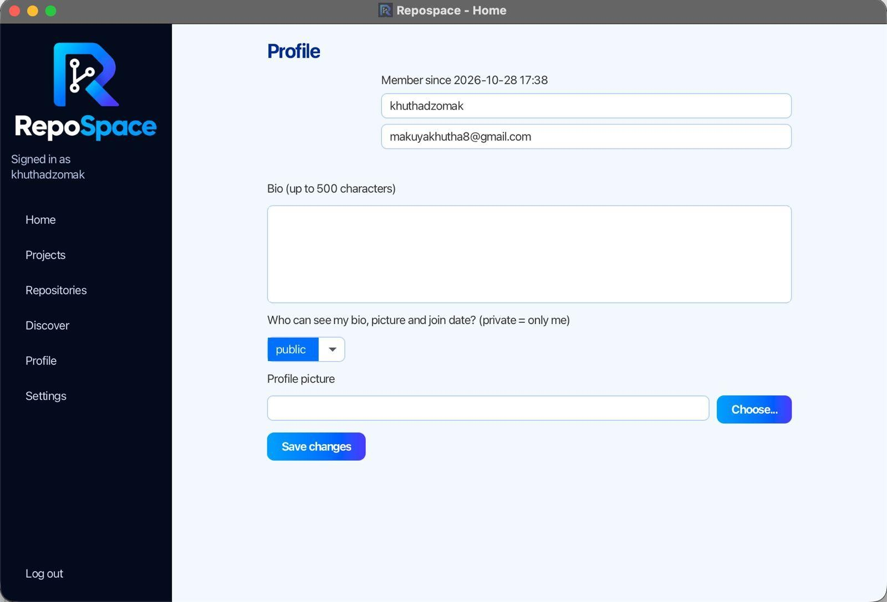
Figure 12: Profile screen with the username, e-mail, bio, visibility and profile picture.
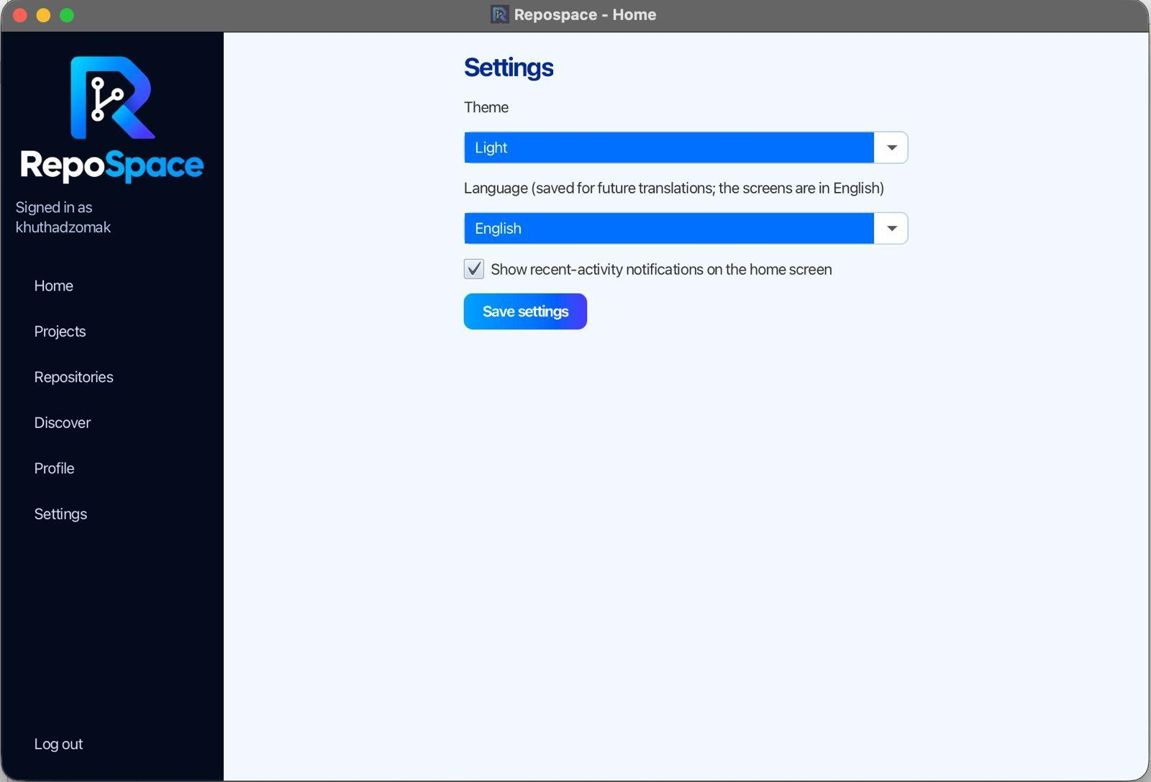
Figure 13: Settings in the light theme.
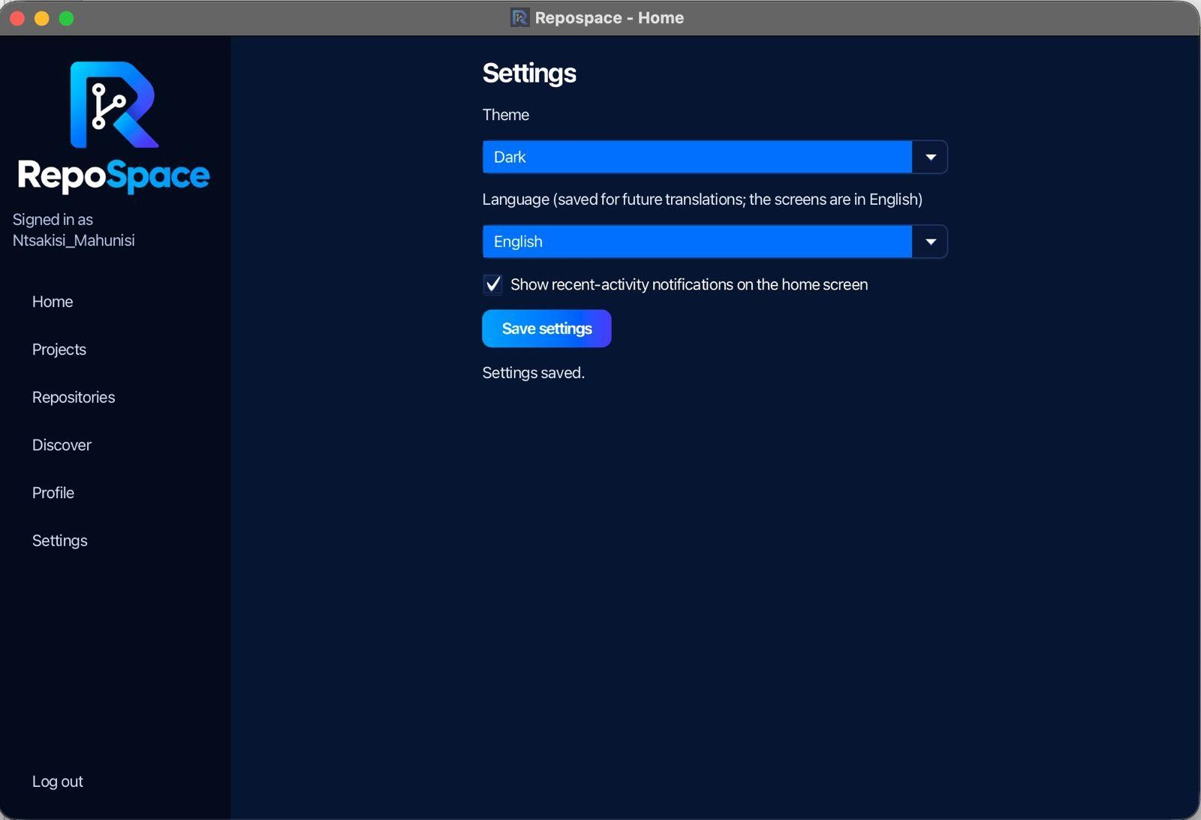
Figure 14: Settings after switching to the dark theme, with the confirmation "Settings saved."

A6. Public and private items
Item | Default | When PUBLIC | When PRIVATE
Project | Private | Every user can see it on your Discover page | Only you
Repository | Private | Every user can browse its history and download the latest version | Only you
Profile | Public | Every user can see your bio, picture and membersince date | Others see only your username
E-mail and password | Never shown |  | Only you can see your email
Only the owner can change visibility. The rule is enforced inside the program’s model classes, not only by hiding buttons, so another user cannot change your settings.

A7. GitHub-style features
These work inside Repospace on your own computer. Where GitHub needs the internet or money, Repospace keeps a local version.
Feature | How to use it
Profile  README and  status | Edit profile, write Markdown and a status, press Save changes, then open My page. Placeholders  such as {{commits}}, {{repos}}, {{streak}}, {{longest-streak}} and {{toplanguage}} are replaced by live numbers
Repository  About and README | Open a repository with Open repository page. Add a description (up to 350 characters), a website and up to 10 topics (lowercase letters, digits and -). The README shown is README.md from your latest commit, otherwise a README written in Repospace
Pinned repositories | Press Pin to my page on a repository. You can pin up to 6
Releases | On the Releases tab enter a tag such as v1.0 and press Publish release. It is fixed to the newest version and its ZIP never changes, even after more commits. Pre-releases are supported
Wiki | On the Wiki tab write several pages. Link pages with [[Page title]]. Revisions are kept. Only the owner can edit
Discussions | On the Discussions tab start a thread in a category (Announcements, General, Ideas, Q&A, Show and tell) and reply. Only the owner posts announcements; the owner or author can close or delete a thread
Project boards | Projects > Open board. Add cards, move them between columns, optionally link a card to a repository
Sponsors | On your page press Sponsor, then Add tier (up to 5 tiers). Other users choose a tier and press Pledge to this tier. Only pledges are recorded; no money moves
Pages | On the Pages tab of a public repository press Turn on Pages, then Open the site in my browser (the address looks like http://localhost:8765/<username>/<repository>/). It shows index.html if there is one, otherwise the README. It works only on your computer while Repospace is open
Statistics and badges | My page shows repositories, commits, current and longest streak, top language, releases and recent activity. Badges are also available as pictures, for example  http://localhost:8765/badges/<username>/commits.svg
Markdown supports headings, bold, italic, code, lists, quotes, code blocks, links and [[wiki links]]. It never runs scripts and only keeps http, https and mailto links. Images are shown as text such as [image: description].

A8. Where your data is stored
Repospace creates a data/ folder next to where it runs:
Path | Contents
data/users.db | Users, profiles, settings, sponsor tiers and pledges
data/login.db | Sign-in attempts
data/software_programme.db | Projects, boards, repositories, commits, history, pins, discussions, releases, wiki pages
data/entry.db | The file list (manifest) of each commit
Path | Contents
data/repos/<id>/objects/ | The saved copies of your files, named by their SHA-256 hash
data/logs/repospace.log | Activity and error log
To use a different location, start Repospace with -Drepospace.data=/path/to/folder.
To back up your work, copy the whole data/ folder. To start again from scratch, close Repospace and delete it.

A8.1 Running the tests
In NetBeans, right-click the project and choose Test (Alt+F6), or in a terminal run: mvn test
There are 77 automated JUnit 5 tests in src/test/java/com/repospace:
Test class | Covers
PasswordUtilTest | Password hashing and verification
FileUtilTest | Recursive listing, SHA-256, recursive delete
SnapshotStoreTest | Snapshots, de-duplication, diff, restore, unsafe path refusal
EdgeCaseTest | Empty, binary and oddly named files, deep folders, 500 files
MarkdownTest | Markdown parsing and safety
VersionControlFlowTest | Register, log in, projects, commit, history, restore, delete
SharingTest | Public/private rules, user search, downloads, database upgrade
CollaborationTest | Pins, discussions, boards, releases, wiki, sponsors
ProfileFeaturesTest | Profile README, About, statistics, badges, Pages server

A9. Troubleshooting
Problem | What to do
Run does nothing in NetBeans | Right-click the project > Run Maven > Goals…, type javafx:run
Dependencies will not download | Check your internet connection for the first build, then Clean and Build again
“Release version 17 not supported” or similar | Your JDK is older than 17. In NetBeans open Tools > Java Platforms, add JDK 17 or newer, and select it in the project properties
Registration says the username is invalid | Use 3 to 30 characters: letters, digits, ., _, -. No spaces
Registration says the password is too short | Use at least 8 characters, for example password123
Restore says the folder must be empty | Choose a new or empty folder. Repospace will not write over existing files
Problem | What to do
Download as ZIP asks for a file name | Type a file name ending in .zip, not just a folder
A repository has nothing to download | Make at least one commit first
Pages link does not open | Pages must be turned on, the repository must be public, and Repospace must still be running. If port 8765 is busy, Repospace picks another one; use the link shown in the  Pages tab
I cannot see another user’s repository | It is private. Only the owner can see or download it
Something went wrong and I need details | Open data/logs/repospace.log

A10. Project structure
Repospace/ pom.xml Maven build (Java 17, JavaFX 21, SQLite, JUnit 5)
README.md This file
DEMO.md Presentation script sandbox/
Sample folders to practise with src/main/java/com/repospace/
Repospace.java Application entry point controller/ Screen logic: Login, Register, Home, Projects,
Repository, Discover, Profile, Settings,
RepoPage, UserPage, Board, Sponsors, Navigator, MarkdownView model/ Business rules: User, Profile, Settings, Projects, Repository, Commit, History,
Release, Discussion, WikiPage, BoardTask,
SponsorTier, Sponsorship, PinnedRepositories,
ProfileStats, Badge, Persistable database/
DatabaseConnection (schema and upgrades) util/
SnapshotStore, FileUtil, PasswordUtil, Markdown, PagesServer, ActivityLogger, DateUtil, Session, Branding src/main/resources/com/repospace/ view/ FXML layouts css/ light.css and dark.css images/ Logo and icons src/test/java/com/repospace/ JUnit tests

A11. How it works
- Content-addressable storage. Each file is stored once under its SHA-256 hash. A commit is a manifest (file path to hash), so unchanged files cost no extra space between versions.
- Diff. Two manifests are compared to list ADDED, MODIFIED and DELETED files.
- Recursion. FileUtil.collect walks folder trees; deleteRecursively removes them; the Markdown reader handles nested styles recursively.
- Collections. Sorted TreeMap manifests, TreeSet of commit days for streaks, an ArrayDeque for the Back button.
- Concurrency. Commits run on a background javafx.concurrent.Task; the Pages server uses a small pool of daemon threads and listens on 127.0.0.1 only.
- Security. Passwords use salted PBKDF2-HMAC-SHA256. All SQL uses prepared statements. Restore and ZIP export refuse paths that would escape the target folder. Permission checks live in the model classes.
- Design. Layered MVC: FXML views, controllers, model, then utilities and database.

A12. Known limitations
- Differences are shown per file (added, modified, deleted), not line by line.
- No branches or merging.
- Empty folders are not tracked (only files are, as in Git).
- Restoring writes the old files into a folder; it does not delete other files.
- The language setting is saved, but the screens are in English only.
- Sponsors record pledges only; no payments are made.
- Pages are visible only on your own computer while Repospace is open.
- There are no collaborators: only the owner edits a repository’s About, releases and wiki.
- Images in a README are shown as text.

Part B: Software Design Report

B1. Introduction

Background
Software is rarely written in one sitting or by one person. Developers need a way to save versions of their work, see what changed, and go back when something breaks. Version control systems such as Git do this, but their commands and concepts can be hard for beginners to learn.

Problem statement
Students and small teams often manage project files by copying folders or sending files to each other. This leads to lost work, overwritten changes and no record of who changed what, or when. Full tools like Git solve this but have a steep learning curve for newcomers. [Check this matches the problem statement from Check-In 1.]

Aim
To design and build Repospace, a simple version control desktop application in
Java and JavaFX that lets users track a folder, save numbered versions
(commits), see what changed, restore any earlier version and share finished work with other users.

Objectives
- Let users register and log in securely with a username or e-mail address.
- Let users track a folder as a repository and save numbered versions (v1, v2, …) with a message.
- Show which files were added, modified or deleted in each version.
- Let users restore any earlier version, clone the latest version, or download it as a ZIP.
- Let users make projects, repositories and profiles public or private, and find and download other users' public work.
- Store all data locally with SQLite, so no database server is needed.
- Document the design with UML and verify it with automated JUnit tests.

B2. Requirements

Functional requirements
ID | Requirement | Main classes
FR1 | Register and log in with a username or e-mail and a password | Login and Register controllers, User, PasswordUtil
FR2 | Create a repository that tracks a folder, as public or private | Repository
FR3 | Commit the folder with a message, stored as v1, v2, … | Commit, SnapshotStore
FR4 | Show ADDED, MODIFIED and DELETED files before a commit and for each version | History, SnapshotStore
FR5 | Restore any version into an empty folder, clone the latest, or download it as a ZIP | Repository, SnapshotStore
FR6 | Manage projects with a status and a kanban board | Projects, BoardTask
FR7 | Search for users and public repositories, and download public repositories | Discover controller, User, Repository
FR8 | Edit profile and settings, including theme and visibility | Profile, Settings
FR9 | GitHub-style extras: pins, releases, wiki, discussions, sponsors, Pages, statistics and badges | PinnedRepositories, Release,  WikiPage, Discussion, SponsorTier,  Sponsorship, PagesServer,  ProfileStats, Badge

Non-functional requirements
ID | Category | Requirement
NFR1 | Security | Passwords are stored only as salted PBKDF2-HMAC- SHA256 hashes
NFR2 | Security | All SQL uses prepared statements; restore and ZIP export refuse paths that escape the target folder
NFR3 | Privacy | Other users never see a user's e-mail; private items are never listed or downloadable; permission checks live in the model classes
NFR4 | Responsiveness | Commits run in the background so the window stays responsive
ID | Category | Requirement
NFR5 | Portability | Runs on Java 17 or newer with no database server
NFR6 | Usability | Light and dark themes; works on screens of 1024 x 768 or larger
NFR7 | Storage efficiency | Unchanged files are stored once and cost no extra space between versions

B3. System architecture
Repospace uses a layered MVC design: FXML views and CSS on top, controllers for screen logic, model classes for the business rules, then utilities and the database layer. Repospace.java is the application entry point. The diagram shows the main classes in each layer.
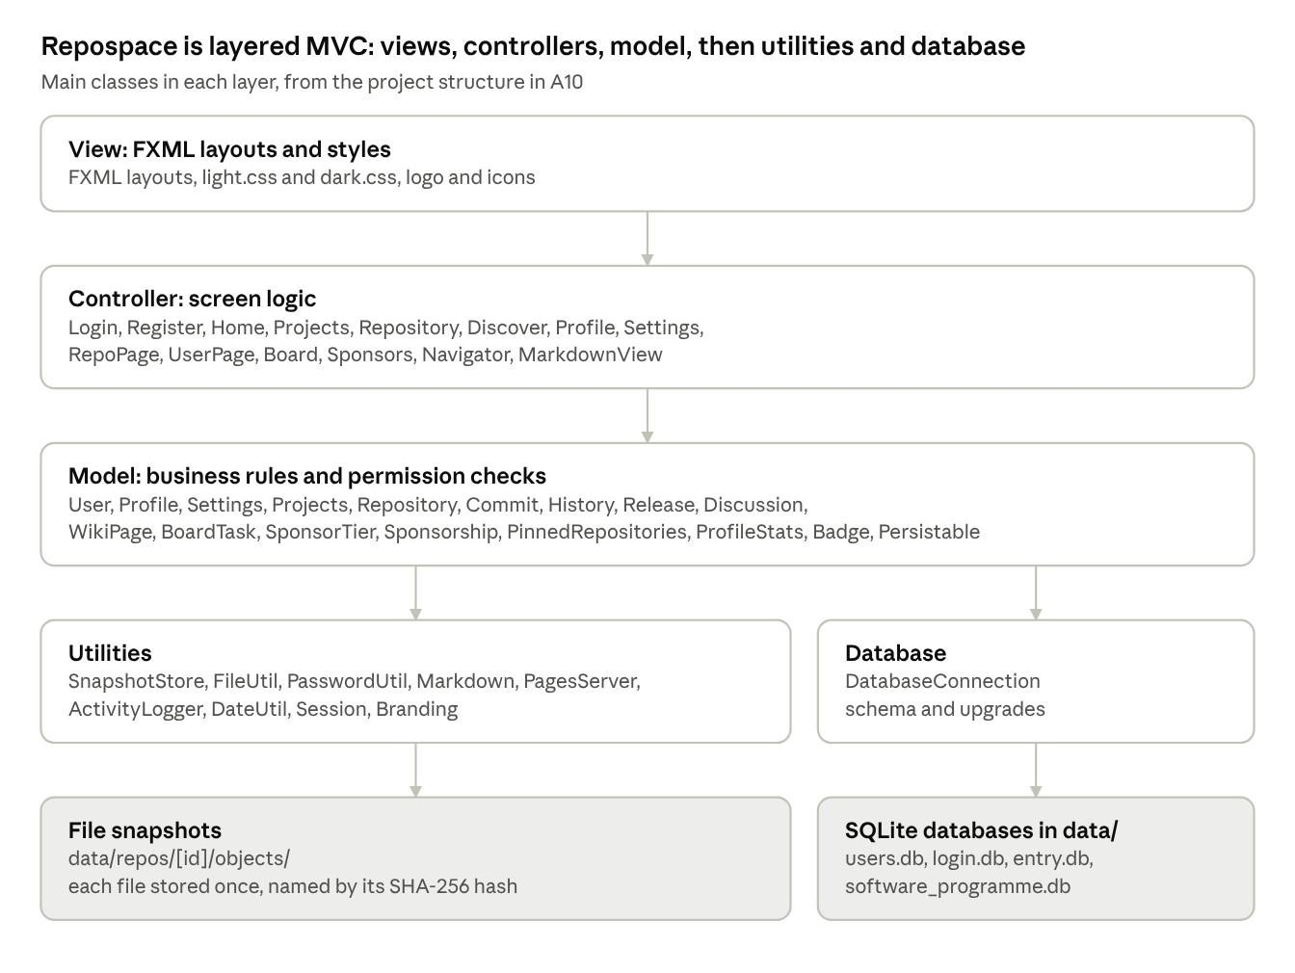

B4. Detailed design: classes

Package | Classes | Responsibility
(root) | Repospace | Application entry point
controller | Login, Register, Home, Projects, Repository,  Discover, Profile, Settings, RepoPage,  UserPage, Board, Sponsors, Navigator,  MarkdownView | Screen logic: responds to the user and calls the model
model | User, Profile, Settings, Projects, Repository,  Commit, History, Release, Discussion,  WikiPage, BoardTask, SponsorTier,  Sponsorship, PinnedRepositories,  ProfileStats, Badge, Persistable | Business rules, including who may see or change each item
database | DatabaseConnection | Database schema and upgrades
util | SnapshotStore, FileUtil, PasswordUtil,  Markdown, PagesServer, ActivityLogger,  DateUtil, Session, Branding | Shared helpers: snapshots, diff and restore; files and hashing; passwords; Markdown; the local Pages server; logging; dates; the logged-in session; branding

B5. Behaviour: key flows
- Logging in: the user enters a username or e-mail and a password → the Login controller checks the password against its salted PBKDF2 hash → the sign-in attempt is recorded in login.db → the Home screen opens.
- Making a commit: the user changes files and presses Check changes → the folder is compared with the last commit's manifest (ADDED, MODIFIED, DELETED) → the user presses Commit → a background task stores new files under their SHA-256 hash and saves the new manifest → the new version (v2, v3, …) appears in the history.

B6. Data design
All data lives in a data/ folder (the full list is in A8): four SQLite databases and a store of file snapshots.
Store |  |  |  |  | Holds
 | users.db |  |  |  | Users, profiles, settings, sponsor tiers and pledges
 | login.db |  |  |  | Sign-in attempts
 | software_programme.db |  |  |  | Projects, boards, repositories, commits, history, pins, discussions, releases, wiki pages
 | entry.db |  |  |  | The manifest (file path to hash) of each commit
 | repos/<id>/objects/ |  |  |  | File contents, each stored once under its SHA-256 hash

B7. Design decisions
Decision | Options considered | Choice | Reason
Interface | Console or graphical | JavaFX 21 with FXML layouts | A friendly graphical interface for beginners, unlike Git's command line
Language  and build | None | Java 17 with Maven | Maven downloads JavaFX, the  SQLite driver and JUnit; builds in  NetBeans or a terminal
Data storage | Database server or embedded database | SQLite | No database server needed; it creates its own files on first start
How commits are stored | Full copies or contentaddressable storage | Each file stored once under its SHA-256 hash; a commit is a manifest | Unchanged files cost no extra space between versions
Architecture | None | Layered MVC | Separates screens, rules and storage; permission checks sit in the model
Passwords | None | Salted PBKDF2-  HMAC-SHA256 | Passwords are never stored as plain text
Project name | Pouch or Repospace | Repospace

B8. Implementation
Repospace is built with Java 17, JavaFX 21, SQLite and Maven. The main techniques:
- Content-addressable storage: each file is stored once under its SHA-256 hash. A commit is a manifest (file path to hash), so unchanged files cost no extra space between versions.
- Diff: two manifests are compared to list ADDED, MODIFIED and DELETED files.
- Recursion: FileUtil.collect walks folder trees, deleteRecursively removes them, and the Markdown reader handles nested styles recursively.
- Collections: sorted TreeMap manifests, a TreeSet of commit days for streaks, and an ArrayDeque for the Back button.
- Concurrency: commits run on a background javafx.concurrent.Task; the Pages server uses a small pool of daemon threads and listens on 127.0.0.1 only.
- Security: passwords use salted PBKDF2-HMAC-SHA256, all SQL uses prepared statements, and restore and ZIP export refuse paths that would escape the target folder.
Add one or two short code extracts here, e.g. how SnapshotStore saves a commit. Keep long code in Appendix E.

B9. Testing

Test class | Covers
PasswordUtilTest | Password hashing and verification
FileUtilTest | Recursive listing, SHA-256, recursive delete
SnapshotStoreTest | Snapshots, de-duplication, diff, restore, unsafe path refusal
EdgeCaseTest | Empty, binary and oddly named files, deep folders, 500 files
MarkdownTest | Markdown parsing and safety
VersionControlFlowTest | Register, log in, projects, commit, history, restore, delete
SharingTest | Public and private rules, user search, downloads, database upgrade
CollaborationTest | Pins, discussions, boards, releases, wiki, sponsors
ProfileFeaturesTest | Profile README, About, statistics, badges, Pages server

B10. Limitations and future improvements
The current limitations are listed in A11; the most important are that there is no branching or merging and differences are shown per file, not line by line. Planned improvements: [agree as a group, e.g. line-by-line differences, branches, collaborators, screens in other languages].

B11. Conclusion
One short paragraph: did Repospace meet the aim and objectives in B1, and what is the main takeaway?

Part C: GA2 and GA7 Reflection

GA2: Application of Scientific and Engineering Knowledge
Our RepoSpace project demonstrates the application of scientific and engineering knowledge through the development of a mini Git-like version control system in Java. It allows users to track file changes, create commits, view history and restore previous versions.

Object-Oriented Programming (OOP)
We used OOP to divide the system into classes with specific responsibilities. The
Repository class manages repository operations, Commit stores commit information, History manages commit records, and User represents users. The VersionControl interface defines the main operations, making the system modular and easier to maintain.

Data Structures and Algorithms
We used HashMap, TreeMap and ArrayList to store and organise repository data. These structures support commit lookups, sorted file tracking and searching commits by ID, message or author.

Recursion
The History class uses recursion to retrieve commit history by following parent commits from the newest to the oldest until it reaches the first commit.

File Handling and Object Serialization
Java file handling and object serialization allow RepoSpace to save and load user accounts, repository data and commit history. File operations also support storing file versions and recording user activity.

Version Control and Data Integrity
RepoSpace uses SHA-256 hashing to generate commit identifiers and identify file content changes. Each commit stores file information, the author, message, timestamp and parent commit. The rollback feature restores previous file versions by creating a new commit without deleting existing history.

Engineering Design and Problem-Solving
We applied software engineering principles by separating system responsibilities into classes and providing a menu for managing files, committing changes, viewing history, searching commits and restoring previous versions.
Through this project, we gained practical experience in applying Java programming, data structures, recursion, file handling and object-oriented design to develop a functional version control system.

GA7: Sustainability and impact of engineering activity
Our project promotes the efficient use of resources by developing a Git-like version control tool that allows developers to manage changes to source code and track the development process. The tool helps reduce the need for multiple copies of project files by allowing developers to maintain and manage different versions of their work in an online place where everyone can access it. This can save storage space and reduce the time required to locate, compare, and restore previous versions of files.

